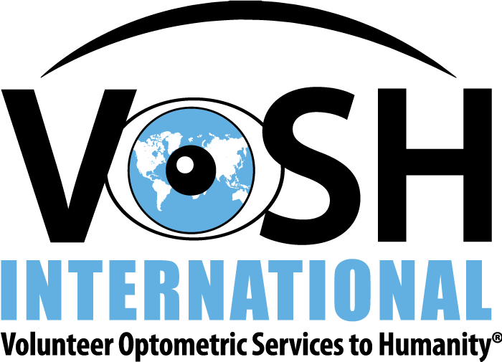

Letter (Template) with Final Team Information
Roster
Flights (arrivals and departures)
Agenda
Host and contact numbers
Host Ophthalmologist
Clinic Site
Baggage and Customs Lists
In-Country Transportation
Hotels
What is Covered by the Mission Fees
Clinic Process for Eye Care
Clinic Process for General Health Care
Emergency numbers
Passports
Things to bring to clinic
– For ODs:
-For Lay Volunteers
Dress Code
Translators
Electricity / Voltage
US Embassy Registration
https://step.state.gov/STEP/Pages/Individuals/AccountInfo.aspx
Phone
Weather
http://www.weather.com/weather/today/l/Guatemala+City+Guatemala+GTXX0002
Currency
Vaccinations
http://wwwnc.cdc.gov/travel/destinations/traveler
R & R:
MISC

