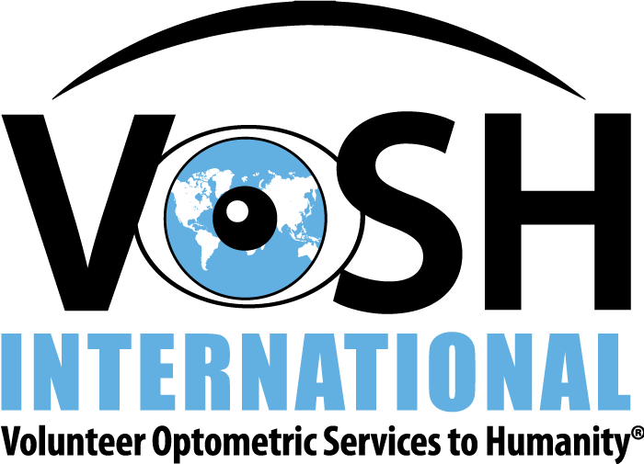

VOSH RELEASE and WAIVER FORM
The undersigned affirms, understands, and agrees that Volunteer Optometric Services to Humanity (“VOSH”) and the mission leaders are volunteering their efforts to coordinate arrangements to benefit the mission, including travel, lodging, and meals (if included), among other things, during the work trip.

In consideration for being allowed to accompany and participate in this mission, I hereby personally assume all risks in connection with this mission and I further release VOSH and the mission leaders from all claims, demands, and actions and for any harm, injury, or damage which my befall me while on the mission, including all risks in connection therewith, whether foreseen or unforeseen, and further I agree to save and hold harmless VOSH and the mission leaders, its representatives, heirs, or assigns, arising out of my participation in this mission. VOSH and the mission leaders will be held harmless for any occurrence in connection with or operation thereof, which may result in injury, death, or other damage to me or my family, heirs, or assigns. Further, VOSH and the mission leaders will not be held responsible for loss of or damage to any equipment, luggage, or personal property taken on the mission.

I further state that I am of lawful age and legally competent to sign this affirmation and release; that I understand the terms herein are contractual and not a mere recital; and, that I have signed this as my own free act. If I am a minor, then my parents and/or authorized guardian are signing this agreement on my behalf.

CHAPTER: _____________________________________________
MISSION: _______________________________________________
DATE: __________________________________________________
SIGNATURE OF APPLICANT: _________________________________
IF APPLICANT IS A MINOR, SIGNATURE OF APPLICANT’S PARENTS OR AUTHORIZED GUARDIAN: _________________________________

